UNIVERSITY INSTITUTE OF COMPUTING

PROJECT REPORT
ON
Online Shopping Management System
Subject Name: Data Base Management System
SUBJECT CODE:25CAT-203

SUBMITED BY:

Name : Barinder singh UID : 25BCD10208

Branch :BCA(Data Science) Group: 25BCD2-B

Semester : Third

SUBMITED TO:

Name : Ms.Harkamal Kaur

Desigination :Assistant Professor
Sign:____________________

2. Certificate
This is to certify that the project report entitled “Online Shopping Management System Using DBMS” has been prepared as part of the academic requirements of the BCA (Data Science) programme at Chandigarh University.
The project demonstrates the design and implementation of a relational database for managing customers, product categories, products, orders, order items, and payment records. It uses MySQL to demonstrate table creation, constraints, data insertion, data retrieval, updates, aggregate functions, joins, indexes, views, and transaction control.
The work has been prepared for academic purposes under the guidance of the concerned faculty member.
Faculty Signature: ____________________
3. Acknowledgement
I would like to express my sincere gratitude to my faculty members for their guidance and support in completing this project, Online Shopping Management System Using DBMS. This project helped me understand the practical application of database management concepts and relational database design.
I am thankful for the opportunity to work with MySQL and practise SQL commands, including data definition, data manipulation, data retrieval, joins, aggregate functions, indexing, views, and transactions. I also acknowledge the support of the university and the learning resources that helped me complete this project.
5. Introduction
Online shopping has become an important part of modern business. Customers can purchase electronic devices, accessories, home appliances, and other products through online platforms without visiting a physical store. Behind an online shopping website, a database is needed to store and organise information about customers, products, orders, and payments.
The Online Shopping Management System is a database project developed using MySQL. It provides a structured way to store customer details, maintain product information, manage stock, record customer orders, and track payment status.
The database contains six main tables: Customers, Categories, Products, Orders, Order_Items, and Payments. These tables are connected through primary keys and foreign keys to maintain relationships between records.
The project also demonstrates practical SQL operations, such as filtering products by price, calculating the average product price, joining customers with their orders, calculating order totals, generating product sales reports, creating indexes and views, and demonstrating a reversible stock update using a transaction.
This project is designed as an academic model of an online shopping database. It focuses on database management rather than developing a complete customer-facing website.
6. Objectives and Problem Statement
6.1 Objectives
- To design a relational database for online shopping.
- To manage customer, product, order, and payment records.
- To maintain product prices, categories, and stock.
- To apply database keys and constraints for data accuracy.
- To retrieve and update data using SQL queries.
- To calculate order totals and generate sales reports.
- To use indexes and views for efficient reporting.
- To demonstrate transaction control using START TRANSACTION and ROLLBACK.
6.2 Problem Statement
In a manually managed shopping business, customer records, product details, stock information, orders, and payments may be stored in separate files or registers. Such a method can make it difficult to locate information, calculate order totals, identify best-selling products, and maintain consistent records.
For example, if a customer purchases a laptop and two headphones, the store needs to identify the customer, record the order, store the quantity and price of each product, calculate the total amount, and record the payment status.
The proposed system uses a relational database to organise these activities. It connects the relevant records using keys and provides SQL queries to retrieve useful information quickly and accurately.
7. Modules and Technologies Used
7.1 Main modules
Module |  |  |  |  |  |  | Purpose
Customer Management |  |  |  |  |  |  | Stores customer names, email addresses, phone numbers, and addresses.
Category Management |  |  |  |  |  |  | Organises products into categories such as Electronics and Accessories.
Product Management |  |  |  |  |  |  | Stores product names, prices, stock quantities, and descriptions.
Order Management |  |  |  |  |  |  | Records order dates, customer references, and order statuses.
Order Item Management |  |  |  |  |  |  | Stores the products, quantities, and recorded unit prices in each order.
Payment Management |  |  |  |  |  |  | Records payment amounts, methods, and payment statuses.
Reporting |  |  |  |  |  |  | Produces order totals, product sales summaries, and customer-order reports.
Transaction Management |  |  |  |  |  |  | Demonstrates how a database change can be rolled back.
7.2 Tools and technologies
Technology | Use in the project
MySQL | Creates and manages the relational database.
SQL | Defines tables, inserts records, updates values, and retrieves information.
MySQL Workbench | Can be used to execute SQL statements and view query results.
Relational database model | Represents data through related tables and keys.
8. Scope of the Project
The project covers the database operations required for a basic online shopping business. It can store multiple customers and products, maintain category information, record orders containing different products, and track payment records.
It also supports useful reports, such as product price lists, customer-order details, order totals, and sales summaries that exclude cancelled orders. Constraints help prevent invalid values, while foreign keys establish relationships between tables.
The current implementation is a database prototype. It does not include a website, user login, a shopping cart interface, live payment processing, automatic stock deduction when an order is placed, or a delivery tracking service. These features could be added in a future version.
Database Design
Table |  |  |  |  |  |  |  |  |  |  | Primary key |  |  |  |  |  |  |  |  |  |  |  |  |  |  | Important columns
Customers |  |  |  |  |  |  |  |  |  |  | Customer_ID |  |  |  |  |  |  |  |  |  |  |  |  |  |  | Name, Email, Phone, Address
Categories |  |  |  |  |  |  |  |  |  |  | Category_ID |  |  |  |  |  |  |  |  |  |  |  |  |  |  | Category_Name
Products |  |  |  |  |  |  |  |  |  |  | Product_ID |  |  |  |  |  |  |  |  |  |  |  |  |  |  | Category_ID, Product_Name, Price, Stock, Description
Orders |  |  |  |  |  |  |  |  |  |  | Order_ID |  |  |  |  |  |  |  |  |  |  |  |  |  |  | Customer_ID, Order_Date, Status
Order_Items |  |  |  |  |  |  |  |  |  |  | Order_Item_ID |  |  |  |  |  |  |  |  |  |  |  |  |  |  | Order_ID, Product_ID, Quantity, Unit_Price
Payments |  |  |  |  |  |  |  |  |  |  | Payment_ID |  |  |  |  |  |  |  |  |  |  |  |  |  |  | Order_ID, Amount, Payment_Method, Payment_Status
11.1 Constraints used
- PRIMARY KEY: Uniquely identifies every record in a table.
- FOREIGN KEY: Connects related tables and helps prevent references to non existent records.
- NOT NULL: Requires a value for the specified column.
- UNIQUE: Prevents duplicate email addresses and category names.
- CHECK: Restricts values, such as positive product prices and valid order statuses.
- DEFAULT: Supplies a default value when one is not explicitly provided.
12. SQL Implementation and Operations Performed
CREATE DATABASE IF NOT EXISTS OnlineShopping;
USE OnlineShopping;

CREATE TABLE Customers (
Customer_ID INT PRIMARY KEY,
Name VARCHAR(60) NOT NULL,
Email VARCHAR(100) NOT NULL UNIQUE,
Phone VARCHAR(15),
Address VARCHAR(150) NOT NULL
);
CREATE TABLE Categories (
Category_ID INT PRIMARY KEY,
Category_Name VARCHAR(50) NOT NULL UNIQUE
);
CREATE TABLE Products (
Product_ID INT PRIMARY KEY,
Category_ID INT NOT NULL,
Product_Name VARCHAR(100) NOT NULL,
Price DECIMAL(10,2) NOT NULL CHECK (Price > 0),
Stock INT NOT NULL DEFAULT 0 CHECK (Stock >= 0),
FOREIGN KEY (Category_ID)
REFERENCES Categories(Category_ID)
);
-- Demonstrate ALTER TABLE
ALTER TABLE Products
ADD Description VARCHAR(200);

CREATE TABLE Orders (
Order_ID INT PRIMARY KEY,
Customer_ID INT NOT NULL,
Order_Date DATE NOT NULL,
Status VARCHAR(20) NOT NULL DEFAULT 'Pending',
FOREIGN KEY (Customer_ID)
REFERENCES Customers(Customer_ID),
CHECK (Status IN
('Pending', 'Shipped', 'Delivered', 'Cancelled'))
);

CREATE TABLE Order_Items (
Order_Item_ID INT PRIMARY KEY,
Order_ID INT NOT NULL,
Product_ID INT NOT NULL,
Quantity INT NOT NULL CHECK (Quantity > 0),
Unit_Price DECIMAL(10,2) NOT NULL
CHECK (Unit_Price > 0),
FOREIGN KEY (Order_ID) REFERENCES Orders(Order_ID),
FOREIGN KEY (Product_ID) REFERENCES Products(Product_ID)
);
CREATE TABLE Payments (
Payment_ID INT PRIMARY KEY,
Order_ID INT NOT NULL,
Amount DECIMAL(10,2) NOT NULL CHECK (Amount >= 0),
Payment_Method VARCHAR(30) NOT NULL,
Payment_Status VARCHAR(20) NOT NULL,
FOREIGN KEY (Order_ID) REFERENCES Orders(Order_ID),
CHECK (Payment_Method IN
('UPI', 'Card', 'Cash on Delivery')),
CHECK (Payment_Status IN ('Pending', 'Paid', 'Failed'))
);

-- 2. INSERT SAMPLE CUSTOMER DATA
INSERT INTO Customers
(Customer_ID, Name, Email, Phone, Address)
VALUES
(1, 'Aman Sharma', 'aman@example.com',
'9876501001', 'Chandigarh'),
(2, 'Riya Verma', 'riya@example.com',
'9876501002', 'Mohali'),
(3, 'Arjun Singh', 'arjun@example.com',
'9876501003', 'Kharar'),
(4, 'Simran Kaur', 'simran@example.com',
'9876501004', 'Ludhiana'),
(5, 'Rahul Mehta', 'rahul@example.com',
'9876501005', 'Patiala');

-- 3. INSERT CATEGORIES
INSERT INTO Categories VALUES
(1, 'Electronics'),
(2, 'Accessories'),
(3, 'Home Appliances');

-- 4. INSERT PRODUCTS
INSERT INTO Products
(Product_ID, Category_ID, Product_Name, Price, Stock, Description)
VALUES
(101, 1, 'Laptop', 55000.00, 10, 'Laptop for study and work'),
(102, 1, 'Smartphone', 25000.00, 20, 'Smartphone with modern features'),
(103, 2, 'Headphones', 1500.00, 50, 'Wired headphones'),
(104, 2, 'Wireless Mouse', 800.00, 40, 'Wireless computer mouse'),
(105, 3, 'Electric Kettle', 1800.00, 15, 'Electric water kettle'),
(106, 1, 'Keyboard', 1200.00, 25, 'Computer keyboard');

-- 5. INSERT ORDERS
INSERT INTO Orders VALUES
(1001, 1, '2026-10-10', 'Delivered'),
(1002, 2, '2026-10-12', 'Shipped'),
(1003, 3, '2026-10-15', 'Pending'),
(1004, 1, '2026-10-18', 'Delivered'),
(1005, 4, '2026-10-20', 'Delivered'),
(1006, 5, '2026-10-21', 'Cancelled');

-- 6. INSERT ORDER ITEMS

INSERT INTO Order_Items VALUES
(1, 1001, 101, 1, 55000.00),
(2, 1001, 103, 2, 1500.00),
(3, 1002, 102, 1, 25000.00),
(4, 1002, 104, 1, 800.00),
(5, 1003, 105, 2, 1800.00),
(6, 1004, 106, 2, 1200.00),
(7, 1005, 103, 3, 1500.00),
(8, 1006, 104, 1, 800.00);

-- 7. INSERT PAYMENT RECORDS
INSERT INTO Payments VALUES
(501, 1001, 58000.00, 'UPI', 'Paid'),
(502, 1002, 25800.00, 'Card', 'Paid'),
(503, 1003, 3600.00, 'UPI', 'Pending'),
(504, 1004, 2400.00, 'Card', 'Paid'),
(505, 1005, 4500.00, 'UPI', 'Paid'),
(506, 1006, 800.00, 'Cash on Delivery', 'Failed');

-- 8. DQL: DISPLAY ALL PRODUCTS
SELECT * FROM Products;

-- 9. SEARCH PRODUCTS WITH A PRICE CONDITION
SELECT Product_ID, Product_Name, Price, Stock
FROM Products
WHERE Price BETWEEN 1000 AND 30000
ORDER BY Price DESC;

-- 10. DML: UPDATE A PRODUCT PRICE
UPDATE Products
SET Price = 1450.00
WHERE Product_ID = 103;

-- 11. AGGREGATE FUNCTIONS
SELECT
COUNT(*) AS Total_Products,
SUM(Stock) AS Total_Stock,
ROUND(AVG(Price), 2) AS Average_Price,
MAX(Price) AS Highest_Price,
MIN(Price) AS Lowest_Price
FROM Products;

-- 12. INNER JOIN: CUSTOMER ORDER DETAILS
SELECT
c.Name AS Customer_Name,
o.Order_ID,
o.Order_Date,
o.Status
FROM Customers c
INNER JOIN Orders o
ON c.Customer_ID = o.Customer_ID
ORDER BY o.Order_ID;

-- 13. LEFT JOIN: CUSTOMERS AND THEIR ORDERS
SELECT
c.Name,
o.Order_ID,
o.Status
FROM Customers c
LEFT JOIN Orders o
ON c.Customer_ID = o.Customer_ID
ORDER BY c.Customer_ID;

-- 14. MULTI-TABLE JOIN: ORDER ITEM DETAILS
SELECT
c.Name AS Customer_Name,
o.Order_ID,
p.Product_Name,
oi.Quantity,
oi.Unit_Price,
oi.Quantity * oi.Unit_Price AS Item_Total,
o.Status
FROM Customers c
JOIN Orders o
ON c.Customer_ID = o.Customer_ID
JOIN Order_Items oi
ON o.Order_ID = oi.Order_ID
JOIN Products p
ON oi.Product_ID = p.Product_ID
ORDER BY o.Order_ID;

-- 15. CALCULATE TOTAL VALUE OF EACH ORDER
SELECT
o.Order_ID,
c.Name AS Customer_Name,
SUM(oi.Quantity * oi.Unit_Price) AS Order_Total
FROM Orders o
JOIN Customers c
ON o.Customer_ID = c.Customer_ID
JOIN Order_Items oi
ON o.Order_ID = oi.Order_ID
GROUP BY o.Order_ID, c.Name
ORDER BY Order_Total DESC;

-- 16. SALES REPORT BY PRODUCT
-- Exclude cancelled orders from the sales report.
SELECT
p.Product_Name,
SUM(oi.Quantity) AS Units_Sold,
SUM(oi.Quantity * oi.Unit_Price) AS Sales_Value
FROM Products p
JOIN Order_Items oi
ON p.Product_ID = oi.Product_ID
JOIN Orders o
ON oi.Order_ID = o.Order_ID
WHERE o.Status <> 'Cancelled'
GROUP BY p.Product_ID, p.Product_Name
ORDER BY Sales_Value DESC;

-- 17. IMPLEMENT INDEXING
CREATE INDEX idx_products_category_price
ON Products(Category_ID, Price);

CREATE INDEX idx_orders_date
ON Orders(Order_Date);

-- Example search using the composite index
SELECT Product_Name, Price
FROM Products
WHERE Category_ID = 1 AND Price < 30000;

-- View existing indexes
SHOW INDEX FROM Products;
SHOW INDEX FROM Orders;

-- 18. CREATE A REPORTING VIEW

CREATE VIEW Order_Report AS
SELECT
c.Name AS Customer_Name,
o.Order_ID,
o.Order_Date,
o.Status,
SUM(oi.Quantity * oi.Unit_Price) AS Order_Total
FROM Customers c
JOIN Orders o
ON c.Customer_ID = o.Customer_ID
JOIN Order_Items oi
ON o.Order_ID = oi.Order_ID
GROUP BY
c.Customer_ID, c.Name,
o.Order_ID, o.Order_Date, o.Status;

SELECT * FROM Order_Report;

-- 19. TRANSACTION EXAMPLE
-- Demonstrate a reversible stock update.

START TRANSACTION;

UPDATE Products
SET Stock = Stock - 1
WHERE Product_ID = 104 AND Stock > 0;

SELECT Product_ID, Product_Name, Stock
FROM Products
WHERE Product_ID = 104;

ROLLBACK;
12.1 Explanation of SQL operations
Operation | Explanation
CREATE DATABASE | Creates the database if it does not already exist.
CREATE TABLE | Creates tables and defines their columns and constraints.
ALTER TABLE | Adds the Description column to Products.
INSERT INTO | Inserts sample customer, category, product, order, order-item, and payment records.
SELECT | Displays records stored in a table.
WHERE | Filters records according to a condition.
BETWEEN | Selects values within an inclusive range.
ORDER BY | Sorts the query results.
UPDATE | Changes the current price of Headphones.
Aggregate functions | Calculate counts, totals, averages, maximums, and minimums.
INNER JOIN | Returns matching customer and order records.
LEFT JOIN | Returns all customers, including those without orders if such customers exist.
GROUP BY | Groups records to calculate order and product totals.
CREATE INDEX | Adds indexes that may improve suitable searches.
CREATE VIEW | Saves a reusable query as Order_Report.
START TRANSACTION | Begins a transaction.
ROLLBACK | Reverses the uncommitted stock update.
13. SQL Queries and Expected Outputs
Insert customer data :
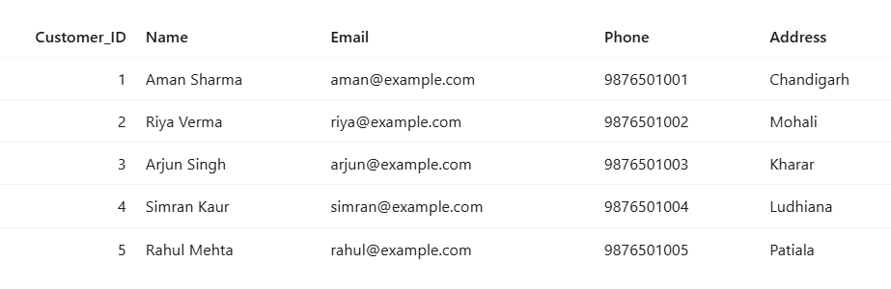
Insert categories
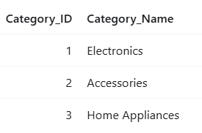
Insert products
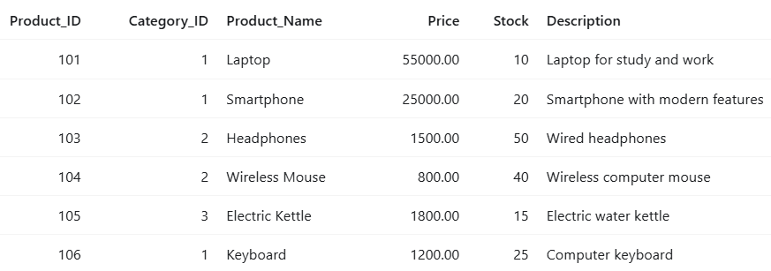
Insert orders
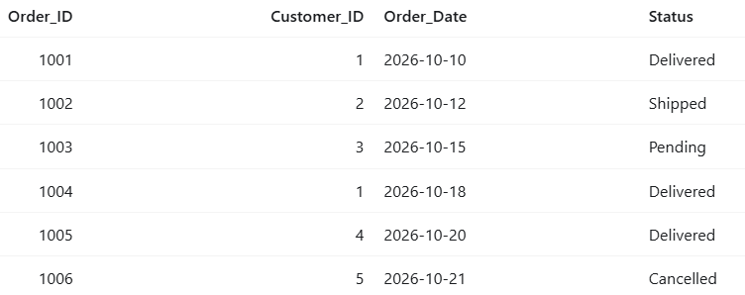
Insert order items
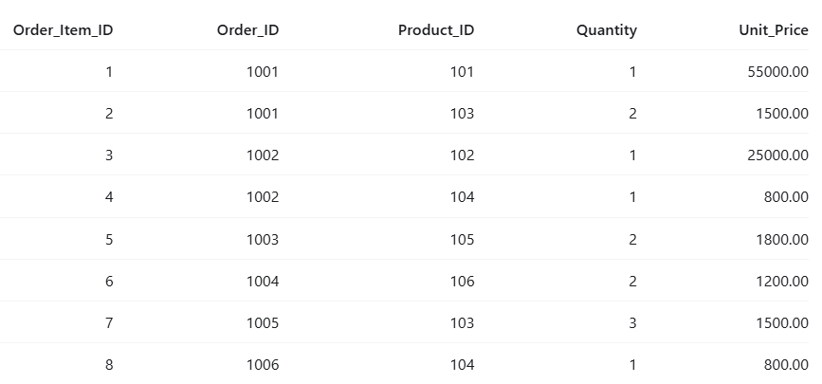
Insert payment records
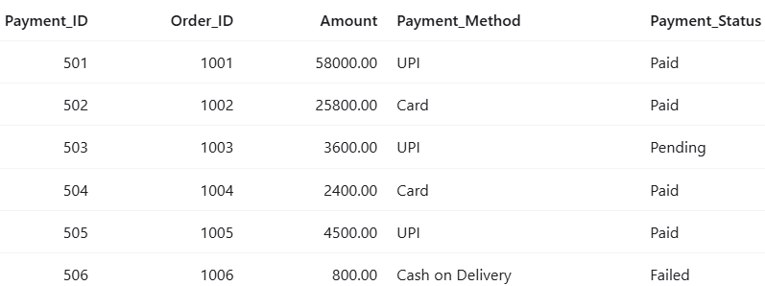
Search products by price
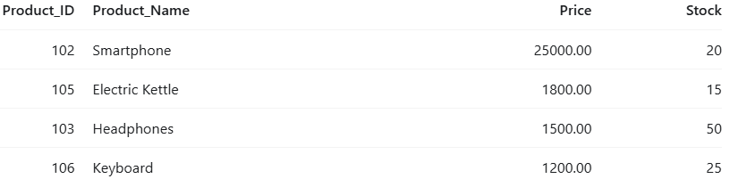
Update the headphones price
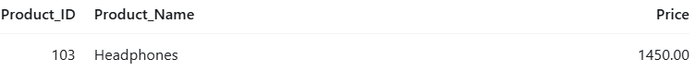
Aggregate functions
Inner Join-customer order details
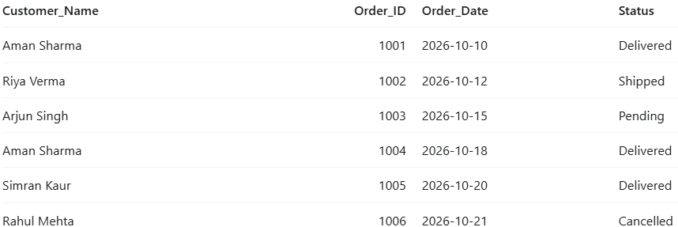
Left join -customer and their orders
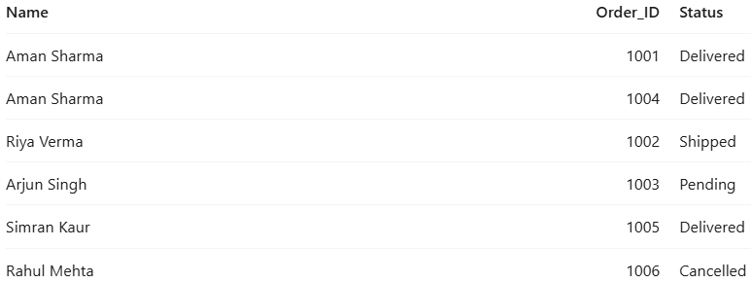
Multi-table join -order item details
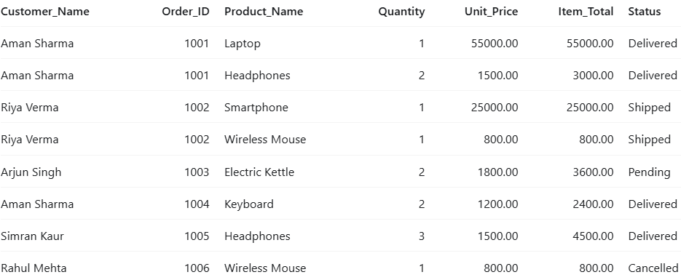
Calculating the total value of each order
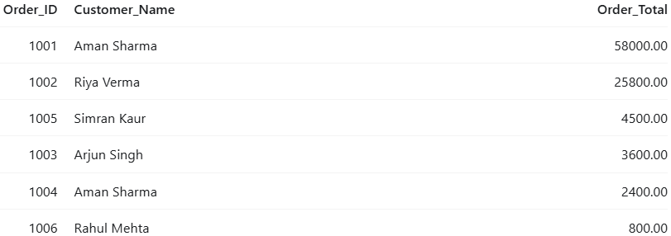
Sales report by Product
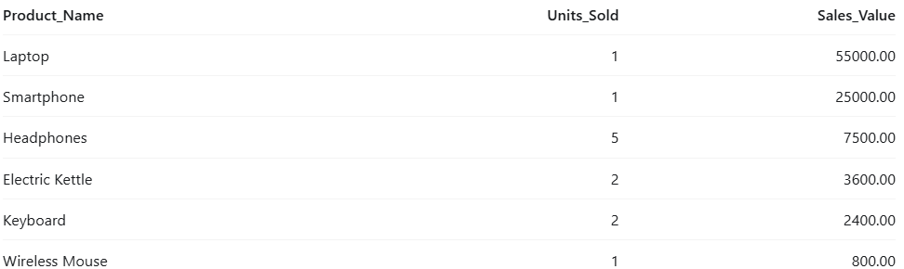
Using Composite Index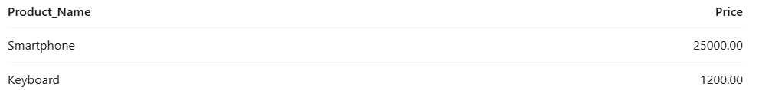

Display the view
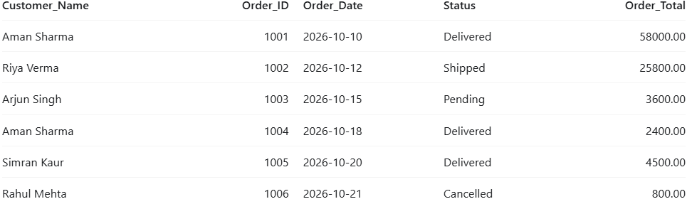

Transaction output
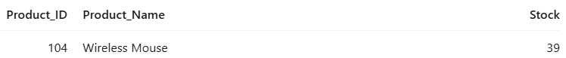
After ROLLBACK
14. Case Study: Online Shopping Management System
14.1 Introduction to the Case Study
Online shopping is a common way for people to purchase products such as laptops, smartphones, headphones, keyboards, and home appliances. Customers can select products, place orders, and make payments without visiting a physical shop.
For this case study, we consider a fictional company named Smart Buy Online Store. The company sells different electronic products and accessories to customers in different cities. As the number of customers and orders increases, the company needs a proper system to maintain its records.
The Online Shopping Management System is developed using MySQL. It stores information about customers, product categories, products, orders, order items, and payments. All the information is organised into six tables so that it can be stored, searched, updated, and managed easily.
The purpose of this case study is to explain how the database works through simple examples and how it helps the company manage its daily shopping activities.
14.2 Background of Smart Buy Online Store
Smart Buy Online Store is a small online shopping business that sells products such as laptops, smartphones, headphones, wireless mice, keyboards, and electric kettles.
In the beginning, the company maintained customer and product information in separate files. As more customers started placing orders, it became difficult to manage all the records manually. Employees needed to check different files to find customer details, product prices, order information, and payment records.
To solve this problem, the company decided to use a database management system. The database provides a common place to store the information and allows employees to retrieve related details through SQL queries.
The database used in this project is named Online Shopping. It is designed to demonstrate the basic operations of a shopping business.
14.3 Problems in the Existing System
Before implementing the database, SmartBuy faced several common problems.
1. Difficulty managing customer information
Customer names, email addresses, phone numbers, and addresses were difficult to organise when maintained in separate records. Searching for a particular customer could take extra time.
2. Difficulty maintaining product details
The store sells several products at different prices. If product information is not organised properly, employees may find it difficult to check the current price or available stock.
3. Problems calculating order totals
A customer may purchase more than one product in a single order. The total amount must be calculated by multiplying the quantity of each product by its price and adding the results.
4. Difficulty checking order status
Customers may have orders that are pending, shipped, delivered, or cancelled. Without organised records, it can be difficult to identify the current status of an order.
5. Difficulty managing payment information
The company needs to record how much a customer paid, which payment method was used, and whether the payment was successful, pending, or failed.
6. Difficulty preparing sales reports
The company may want to know which products sell frequently and which products generate more sales. Preparing such reports manually can take additional time.
These problems show why the company needs a structured database to maintain its shopping records.
14.4 Objectives of the Case Study
The main objectives are:
- To create a database for Smart Buy Online Store.
- To store customer information in an organised form.
- To maintain product names, prices, stock, and categories.
- To record customer orders and their statuses.
- To store the products included in each order.
- To maintain payment details.
- To calculate order totals using SQL queries.
- To generate simple product sales reports.
- To understand the use of primary keys and foreign keys.
- To demonstrate basic SQL operations such as inserting, updating, searching, and displaying records.
14.5 Proposed Solution
To solve the problems, Smart Buy uses a MySQL database with six tables.
Table name | Information stored
Customers | Customer names, email addresses, phone numbers, and addresses
Categories | Product category names
Products | Product names, prices, stock quantities, and descriptions
Orders | Order dates, customer references, and order statuses
Order_Items | Products, quantities, and prices included in each order
Payments | Payment amounts, methods, and payment statuses
Each table has a specific purpose. The tables are connected using primary keys and foreign keys.
For example, the Customers table identifies a customer through Customer_ID. The Orders table uses the same customer ID to identify who placed an order. Similarly, Order_Items connects an order with the products purchased.
This arrangement reduces unnecessary repetition and makes it easier to retrieve related information.
14.6 Customer Information
Smart Buy maintains information about five sample customers.
Customer ID |  |  |  |  |  |  |  |  | Customer name |  |  |  |  |  |  |  |  |  |  |  | City
1 |  |  |  |  |  |  |  |  | Aman Sharma |  |  |  |  |  |  |  |  |  |  |  | Chandigarh
2 |  |  |  |  |  |  |  |  | Riya Verma |  |  |  |  |  |  |  |  |  |  |  | Mohali
3 |  |  |  |  |  |  |  |  | Arjun Singh |  |  |  |  |  |  |  |  |  |  |  | Kharar
4 |  |  |  |  |  |  |  |  | Simran Kaur |  |  |  |  |  |  |  |  |  |  |  | Ludhiana
5 |  |  |  |  |  |  |  |  | Rahul Mehta |  |  |  |  |  |  |  |  |  |  |  | Patiala
The Customers table stores the complete details, including each customer's email address, phone number, and address.
When a customer places an order, the database uses the customer ID to connect the order to the correct customer. This helps the company find a customer's order history without repeating all their personal details in the order record.
For example, Aman Sharma has Customer ID 1. Whenever the Orders table contains Customer ID 1, the company can identify the order as belonging to Aman by joining the two tables.
14.7 Product Management
Smart Buy sells products belonging to different categories. The database contains three categories: Electronics, Accessories, and Home Appliances.
The following table shows the sample products.
Product ID |  |  |  |  |  |  |  |  |  |  | Product name |  |  |  |  |  |  |  |  |  |  |  | Price (₹) |  |  |  |  |  |  |  |  |  |  |  |  |  |  |  | Stock
101 |  |  |  |  |  |  |  |  |  |  | Laptop |  |  |  |  |  |  |  |  |  |  |  | 55,000 |  |  |  |  |  |  |  |  |  |  |  |  |  |  |  | 10
102 |  |  |  |  |  |  |  |  |  |  | Smartphone |  |  |  |  |  |  |  |  |  |  |  | 25,000 |  |  |  |  |  |  |  |  |  |  |  |  |  |  |  | 20
103 |  |  |  |  |  |  |  |  |  |  | Headphones |  |  |  |  |  |  |  |  |  |  |  | 1,500 initially |  |  |  |  |  |  |  |  |  |  |  |  |  |  |  | 50
104 |  |  |  |  |  |  |  |  |  |  | Wireless Mouse |  |  |  |  |  |  |  |  |  |  |  | 800 |  |  |  |  |  |  |  |  |  |  |  |  |  |  |  | 40
105 |  |  |  |  |  |  |  |  |  |  | Electric Kettle |  |  |  |  |  |  |  |  |  |  |  | 1,800 |  |  |  |  |  |  |  |  |  |  |  |  |  |  |  | 15
106 |  |  |  |  |  |  |  |  |  |  | Keyboard |  |  |  |  |  |  |  |  |  |  |  | 1,200 |  |  |  |  |  |  |  |  |  |  |  |  |  |  |  | 25
The Products table stores each product's ID, category, name, price, stock quantity, and description.
The company can use SQL to display all products or search for products within a particular price range. For example, the store can retrieve products priced between ₹1,000 and ₹30,000.
The project also demonstrates updating the Headphones price from ₹1,500 to ₹1,450. After the update, the current catalogue price becomes ₹1,450, while the earlier order records retain their recorded unit price.
14.8 Order Management
When a customer purchases products, SmartBuy creates an order record. Each order has a unique order ID, a customer ID, an order date, and an order status.
The sample database contains six orders.
Order ID |  |  | Customer |  |  |  |  |  |  |  |  | Order date |  |  |  |  |  |  |  | Status
1001 |  |  | Aman Sharma |  |  |  |  |  |  |  |  | 10 October 2026 |  |  |  |  |  |  |  | Delivered
1002 |  |  | Riya Verma |  |  |  |  |  |  |  |  | 12 October 2026 |  |  |  |  |  |  |  | Shipped
1003 |  |  | Arjun Singh |  |  |  |  |  |  |  |  | 15 October 2026 |  |  |  |  |  |  |  | Pending
1004 |  |  | Aman Sharma |  |  |  |  |  |  |  |  | 18 October 2026 |  |  |  |  |  |  |  | Delivered
1005 |  |  | Simran Kaur |  |  |  |  |  |  |  |  | 20 October 2026 |  |  |  |  |  |  |  | Delivered
1006 |  |  | Rahul Mehta |  |  |  |  |  |  |  |  | 21 October 2026 |  |  |  |  |  |  |  | Cancelled
The company can use the order status to understand the progress of an order. A pending order has not yet reached a completed stage, a shipped order is in transit, and a delivered order has reached its destination. A cancelled order is not included in the project's product sales report.
The SQL code uses a CHECK constraint to restrict the status to the allowed values. This helps prevent invalid status entries.
14.9 Managing Products Within an Order
An order can contain one product or several products. Therefore, the project uses the Order_Items table to store the individual products included in each order.
For example, Order ID 1001 contains one laptop and two headphones.
Product |  |  |  |  |  |  |  |  | Quantity |  |  |  |  |  |  |  | Recorded unit price |  |  |  |  |  |  |  |  | Item total
Laptop |  |  |  |  |  |  |  |  | 1 |  |  |  |  |  |  |  | ₹55,000 |  |  |  |  |  |  |  |  | ₹55,000
Headphones |  |  |  |  |  |  |  |  | 2 |  |  |  |  |  |  |  | ₹1,500 |  |  |  |  |  |  |  |  | ₹3,000
Total |  |  |  |  |  |  |  |  |  |  |  |  |  |  |  |  |  |  |  |  |  |  |  |  |  | ₹58,000
The item total is calculated by multiplying the quantity by the recorded unit price.
The Order_Items table is useful because it allows one order to contain multiple products without creating a separate order record for every product. It also keeps the price recorded for the order, even if the current catalogue price changes later.
14.10 Payment Management
SmartBuy also maintains payment information for its orders. The Payments table stores the payment ID, order ID, amount, payment method, and payment status.
Payment ID |  |  |  |  |  |  | Order ID |  |  |  |  |  |  |  |  |  |  | Amount |  |  |  |  |  |  |  |  |  |  | Method |  |  |  |  |  |  | Status
501 |  |  |  |  |  |  | 1001 |  |  |  |  |  |  |  |  |  |  | ₹58,000 |  |  |  |  |  |  |  |  |  |  | UPI |  |  |  |  |  |  | Paid
502 |  |  |  |  |  |  | 1002 |  |  |  |  |  |  |  |  |  |  | ₹25,800 |  |  |  |  |  |  |  |  |  |  | Card |  |  |  |  |  |  | Paid
503 |  |  |  |  |  |  | 1003 |  |  |  |  |  |  |  |  |  |  | ₹3,600 |  |  |  |  |  |  |  |  |  |  | UPI |  |  |  |  |  |  | Pending
504 |  |  |  |  |  |  | 1004 |  |  |  |  |  |  |  |  |  |  | ₹2,400 |  |  |  |  |  |  |  |  |  |  | Card |  |  |  |  |  |  | Paid
505 |  |  |  |  |  |  | 1005 |  |  |  |  |  |  |  |  |  |  | ₹4,500 |  |  |  |  |  |  |  |  |  |  | UPI |  |  |  |  |  |  | Paid
506 |  |  |  |  |  |  | 1006 |  |  |  |  |  |  |  |  |  |  | ₹800 |  |  |  |  |  |  |  |  |  |  | Cash on Delivery |  |  |  |  |  |  | Failed
These records help the company identify the amount associated with an order and the current payment status.
For example, Order ID 1001 has a payment amount of ₹58,000 and a payment status of Paid. Order ID 1003 has a payment status of Pending, while Order ID 1006 has a failed payment record.
The project stores these payment records in the database. It does not actually process money or connect to a payment service.
14.11 Practical Example: Aman Sharma Places an Order
Consider a simple situation in which Aman Sharma purchases one laptop and two headphones from Smart Buy Online Store.
First, the company identifies Aman through Customer ID 1. It then records the order with Order ID 1001 and the order date 10 October 2026.
Next, the products are recorded in the Order_Items table. One row represents the laptop, and another row represents the headphones. Each row contains the product ID, quantity, and recorded unit price.
The total amount is calculated as follows:
- Laptop: 1 × ₹55,000 = ₹55,000
- Headphones: 2 × ₹1,500 = ₹3,000
- Total order amount: ₹55,000 + ₹3,000 = ₹58,000
The company records the payment of ₹58,000 in the Payments table. The order status is Delivered, and the payment status is Paid.
This example shows how different tables work together. Customer details are stored in Customers, order details in Orders, product quantities in Order_Items, and payment information in Payments.
14.12 SQL Operations Used in the Case Study
The project uses several SQL operations to manage SmartBuy's records.
Creating tables: The CREATE TABLE statements create the six tables required by the system.
Inserting records: The INSERT INTO statements add sample customers, categories, products, orders, order items, and payments.
Displaying products: The SELECT statement displays the product records stored in the database.
Searching by price: The WHERE and BETWEEN clauses select products within a specified price range.
Updating prices: The UPDATE statement changes the current Headphones price to ₹1,450.
Calculating totals: The SUM() function calculates the value of each order by adding the item totals.
Joining tables: The JOIN statements combine customer names, order information, and product details.
Creating a sales report: The sales query groups records by product and excludes cancelled orders.
Creating a view: The Order_Report view provides a reusable report containing customer names, order dates, statuses, and totals.
Using a transaction: The transaction example temporarily decreases the stock of Wireless Mouse and then uses ROLLBACK to reverse the change.
Code:
-- =========================================================
-- SMART BUY ONLINE STORE
-- Database Management System case study

CREATE DATABASE IF NOT EXISTS `Online Shopping`;
USE `Online Shopping`;
CREATE TABLE Customers (
Customer_ID INT PRIMARY KEY,
Customer_Name VARCHAR(100) NOT NULL,
Email VARCHAR(150) NOT NULL UNIQUE,
Phone VARCHAR(20),
Address VARCHAR(255),
City VARCHAR(80) NOT NULL
);
CREATE TABLE Categories (
Category_ID INT PRIMARY KEY,
Category_Name VARCHAR(80) NOT NULL UNIQUE
);
CREATE TABLE Products (
Product_ID INT PRIMARY KEY,
Category_ID INT NOT NULL,
Product_Name VARCHAR(120) NOT NULL,
Price DECIMAL(10, 2) NOT NULL CHECK (Price >= 0),
Stock INT NOT NULL CHECK (Stock >= 0),
Description VARCHAR(255),
CONSTRAINT fk_products_category
FOREIGN KEY (Category_ID)
REFERENCES Categories(Category_ID)
);
CREATE TABLE Orders (
Order_ID INT PRIMARY KEY,
Customer_ID INT NOT NULL,
Order_Date DATE NOT NULL,
Status VARCHAR(20) NOT NULL,
CONSTRAINT chk_order_status
CHECK (Status IN ('Pending', 'Shipped', 'Delivered', 'Cancelled')),

CONSTRAINT fk_orders_customer
FOREIGN KEY (Customer_ID)
REFERENCES Customers(Customer_ID)
);
CREATE TABLE Order_Items (
Order_Item_ID INT PRIMARY KEY AUTO_INCREMENT,
Order_ID INT NOT NULL,
Product_ID INT NOT NULL,
Quantity INT NOT NULL CHECK (Quantity > 0),
Recorded_Unit_Price DECIMAL(10, 2) NOT NULL
CHECK (Recorded_Unit_Price >= 0),
CONSTRAINT fk_order_items_order
FOREIGN KEY (Order_ID)
REFERENCES Orders(Order_ID),
CONSTRAINT fk_order_items_product
FOREIGN KEY (Product_ID)
REFERENCES Products(Product_ID),
-- A product appears at most once in a particular order.
CONSTRAINT uq_order_product
UNIQUE (Order_ID, Product_ID)
);
CREATE TABLE Payments (
Payment_ID INT PRIMARY KEY,
Order_ID INT NOT NULL,
Amount DECIMAL(10, 2) NOT NULL CHECK (Amount >= 0),
Payment_Method VARCHAR(30) NOT NULL,
Payment_Status VARCHAR(20) NOT NULL,
CONSTRAINT chk_payment_status
CHECK (Payment_Status IN ('Paid', 'Pending', 'Failed')),
CONSTRAINT fk_payments_order
FOREIGN KEY (Order_ID)
REFERENCES Orders(Order_ID)
);
-- =========================================================
-- 2. ADD INDEXES FOR COMMON SEARCHES
-- =========================================================
CREATE INDEX idx_products_name
ON Products(Product_Name);
CREATE INDEX idx_products_price
ON Products(Price);
CREATE INDEX idx_orders_customer_date
ON Orders(Customer_ID, Order_Date);
CREATE INDEX idx_orders_status
ON Orders(Status);
CREATE INDEX idx_order_items_product
ON Order_Items(Product_ID);
-- =========================================================
-- 3. INSERT SAMPLE CUSTOMERS
-- =========================================================
INSERT INTO Customers
(Customer_ID, Customer_Name, Email, Phone, Address, City)
VALUES
(1, 'Aman Sharma', 'aman@example.com', '9876500001',
'Sector 17', 'Chandigarh'),
(2, 'Riya Verma', 'riya@example.com', '9876500002',
'Phase 7', 'Mohali'),
(3, 'Arjun Singh', 'arjun@example.com', '9876500003',
'Sunny Enclave', 'Kharar'),
(4, 'Simran Kaur', 'simran@example.com', '9876500004',
'Model Town', 'Ludhiana'),
(5, 'Rahul Mehta', 'rahul@example.com', '9876500005',
'Tripuri', 'Patiala');
-- =========================================================
-- 4. INSERT PRODUCT CATEGORIES
-- =========================================================
INSERT INTO Categories (Category_ID, Category_Name)
VALUES
(1, 'Electronics'),
(2, 'Accessories'),
(3, 'Home Appliances');
-- =========================================================
-- 5. INSERT PRODUCTS
-- =========================================================
INSERT INTO Products
(Product_ID, Category_ID, Product_Name, Price, Stock, Description)
VALUES
(101, 1, 'Laptop', 55000.00, 10,
'Laptop for work and study'),
(102, 1, 'Smartphone', 25000.00, 20,
'Smartphone with a large display'),
(103, 1, 'Headphones', 1500.00, 50,
'Wired over-ear headphones'),
(104, 2, 'Wireless Mouse', 800.00, 40,
'Wireless optical mouse'),
(105, 3, 'Electric Kettle', 1800.00, 15,
'Electric kettle for home use'),
(106, 2, 'Keyboard', 1200.00, 25,
'USB computer keyboard');
-- =========================================================
-- 6. INSERT SAMPLE ORDERS
-- =========================================================
INSERT INTO Orders (Order_ID, Customer_ID, Order_Date, Status)
VALUES
(1001, 1, '2026-10-10', 'Delivered'),
(1002, 2, '2026-10-12', 'Shipped'),
(1003, 3, '2026-10-15', 'Pending'),
(1004, 1, '2026-10-18', 'Delivered'),
(1005, 4, '2026-10-20', 'Delivered'),
(1006, 5, '2026-10-21', 'Cancelled');
-- =========================================================
-- 7. INSERT ORDER ITEMS
-- =========================================================
INSERT INTO Order_Items
(Order_ID, Product_ID, Quantity, Recorded_Unit_Price)
VALUES
-- Order 1001: one laptop and two headphones = ₹58,000
(1001, 101, 1, 55000.00),
(1001, 103, 2, 1500.00),
-- Order 1002: one smartphone and one wireless mouse = ₹25,800
(1002, 102, 1, 25000.00),
(1002, 104, 1, 800.00),
-- Order 1003: two electric kettles = ₹3,600
(1003, 105, 2, 1800.00),
-- Order 1004: two keyboards = ₹2,400
(1004, 106, 2, 1200.00),
-- Order 1005: three headphones = ₹4,500
(1005, 103, 3, 1500.00),
-- Order 1006: cancelled order; excluded from sales reports
(1006, 104, 1, 800.00);
-- =========================================================
-- 8. INSERT PAYMENT RECORDS
-- This project stores payment information; it does not process
-- real payments or connect to a payment service.
-- =========================================================
INSERT INTO Payments
(Payment_ID, Order_ID, Amount, Payment_Method, Payment_Status)
VALUES
(501, 1001, 58000.00, 'UPI', 'Paid'),
(502, 1002, 25800.00, 'Card', 'Paid'),
(503, 1003, 3600.00, 'UPI', 'Pending'),
(504, 1004, 2400.00, 'Card', 'Paid'),
(505, 1005, 4500.00, 'UPI', 'Paid'),
(506, 1006, 800.00, 'Cash on Delivery', 'Failed');
-- =========================================================
-- 9. DISPLAY THE TABLE DATA
-- =========================================================
SELECT * FROM Customers;
SELECT * FROM Categories;
SELECT * FROM Products;
SELECT * FROM Orders;
SELECT * FROM Order_Items;
SELECT * FROM Payments;
-- =========================================================
-- 10. SEARCH PRODUCTS WITHIN A PRICE RANGE
-- =========================================================
SELECT Product_ID, Product_Name, Price, Stock
FROM Products
WHERE Price BETWEEN 1000 AND 30000
ORDER BY Price;
-- =========================================================
-- 11. UPDATE THE HEADPHONES CATALOGUE PRICE
.-- =========================================================
UPDATE Products
SET Price = 1450.00
WHERE Product_ID = 103;
SELECT Product_ID, Product_Name, Price
FROM Products
WHERE Product_ID = 103;
-- Show current catalogue price next to the historical order price.
SELECT
oi.Order_ID,
p.Product_Name,
oi.Quantity,
oi.Recorded_Unit_Price AS Price_At_Purchase,
p.Price AS Current_Catalogue_Price
FROM Order_Items AS oi
JOIN Products AS p
ON p.Product_ID = oi.Product_ID
WHERE p.Product_ID = 103;
-- =========================================================
-- 12. CALCULATE EACH ORDER TOTAL
-- Cancelled orders are included in this general order listing.
-- =========================================================
SELECT
o.Order_ID,
c.Customer_Name,
o.Order_Date,
o.Status,
SUM(oi.Quantity * oi.Recorded_Unit_Price) AS Order_Total
FROM Orders AS o
JOIN Customers AS c
ON c.Customer_ID = o.Customer_ID
JOIN Order_Items AS oi
ON oi.Order_ID = o.Order_ID
GROUP BY
o.Order_ID,
c.Customer_Name,
o.Order_Date,
o.Status
ORDER BY o.Order_ID;
- =========================================================
-- 13. DISPLAY A CUSTOMER'S ORDER HISTORY
-- Example: Aman Sharma, Customer_ID 1
-- =========================================================
SELECT
c.Customer_Name,
o.Order_ID,
o.Order_Date,
o.Status
FROM Customers AS c
JOIN Orders AS o
ON o.Customer_ID = c.Customer_ID
WHERE c.Customer_ID = 1
ORDER BY o.Order_Date;
-- =========================================================
-- 14. DISPLAY PRODUCT DETAILS FOR EACH ORDER
-- =========================================================
SELECT
o.Order_ID,
c.Customer_Name,
p.Product_Name,
oi.Quantity,
oi.Recorded_Unit_Price,
oi.Quantity * oi.Recorded_Unit_Price AS Item_Total
FROM Orders AS o
JOIN Customers AS c
ON c.Customer_ID = o.Customer_ID
JOIN Order_Items AS oi
ON oi.Order_ID = o.Order_ID
JOIN Products AS p
ON p.Product_ID = oi.Product_ID
ORDER BY o.Order_ID, p.Product_Name;
-- =========================================================
-- 15. CREATE A SALES REPORT
-- Cancelled orders are excluded.
-- =========================================================
SELECT
p.Product_ID,
p.Product_Name,
SUM(oi.Quantity) AS Units_Sold,
SUM(oi.Quantity * oi.Recorded_Unit_Price) AS Sales_Value
FROM Order_Items AS oi
JOIN Orders AS o
ON o.Order_ID = oi.Order_ID
JOIN Products AS p
ON p.Product_ID = oi.Product_ID
WHERE o.Status <> 'Cancelled'
GROUP BY p.Product_ID, p.Product_Name
ORDER BY Sales_Value DESC;

-- =========================================================
-- 16. CREATE A REUSABLE ORDER REPORT VIEW
-- =========================================================
CREATE VIEW Order_Report AS
SELECT
o.Order_ID,
c.Customer_Name,
o.Order_Date,
o.Status,
COALESCE(
SUM(oi.Quantity * oi.Recorded_Unit_Price),
0
) AS Order_Total
FROM Orders AS o
JOIN Customers AS c
ON c.Customer_ID = o.Customer_ID
LEFT JOIN Order_Items AS oi
ON oi.Order_ID = o.Order_ID
GROUP BY
o.Order_ID,
c.Customer_Name,
o.Order_Date,
o.Status;
-- Display the view.
SELECT * FROM Order_Report
ORDER BY Order_ID;
-- =========================================================
-- 17. DISPLAY PAYMENT STATUS WITH ORDER INFORMATION
-- =========================================================
SELECT
o.Order_ID,
c.Customer_Name,
p.Amount,
p.Payment_Method,
p.Payment_Status
FROM Payments AS p
JOIN Orders AS o
ON o.Order_ID = p.Order_ID
JOIN Customers AS c
ON c.Customer_ID = o.Customer_ID
ORDER BY o.Order_ID;
-- =========================================================
-- 18. TRANSACTION EXAMPLE
-- Reduce wireless mouse stock temporarily, then undo it.
-- ROLLBACK restores the original stock quantity.
-- =========================================================
START TRANSACTION;
UPDATE Products
SET Stock = Stock - 1
WHERE Product_ID = 104
AND Stock >= 1;

SELECT Product_ID, Product_Name, Stock
FROM Products
WHERE Product_ID = 104;

ROLLBACK;
-- Confirm that the original stock quantity is restored.
SELECT Product_ID, Product_Name, Stock
FROM Products
WHERE Product_ID = 104;
-- =========================================================
-- 19. SUMMARY QUERIES
-- =========================================================
-- Count records in each main table.
SELECT 'Customers' AS Table_Name, COUNT(*) AS Record_Count
FROM Customers
UNION ALL
SELECT 'Categories', COUNT(*) FROM Categories
UNION ALL
SELECT 'Products', COUNT(*) FROM Products
UNION ALL
SELECT 'Orders', COUNT(*) FROM Orders
UNION ALL
SELECT 'Order_Items', COUNT(*) FROM Order_Items
UNION ALL
SELECT 'Payments', COUNT(*) FROM Payments;
-- Total units currently listed in product stock.
SELECT SUM(Stock) AS Total_Units_In_Stock
FROM Products;
-- Count orders by status.
SELECT Status, COUNT(*) AS Number_Of_Orders
FROM Orders
GROUP BY Status
ORDER BY Status;
OUTPUT:
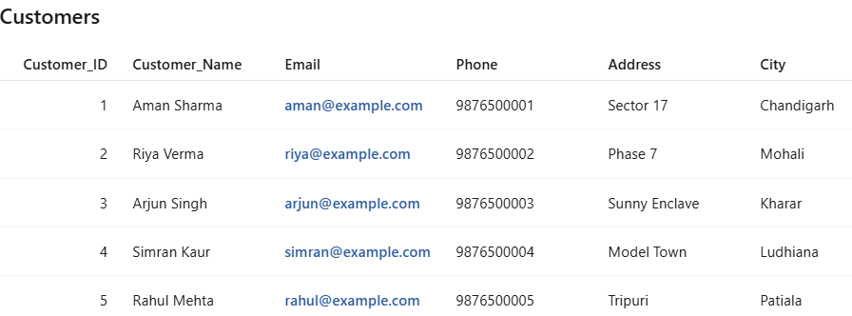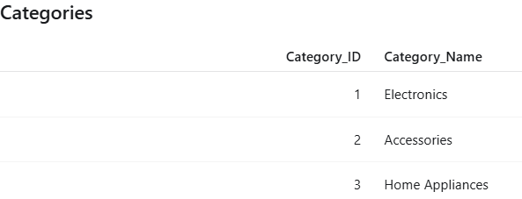
Product -before the price update
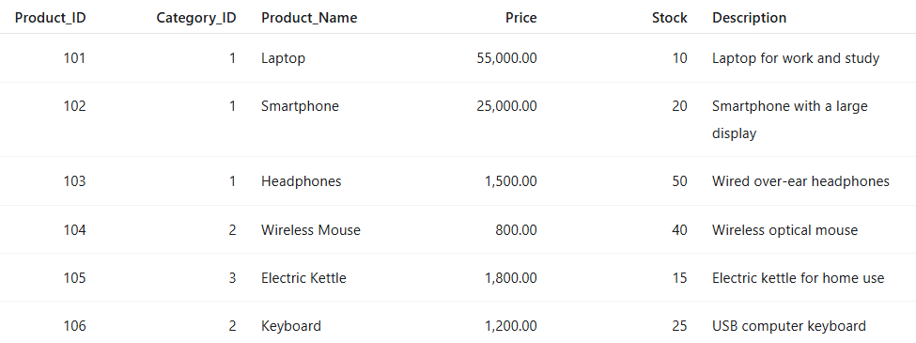
Order items:
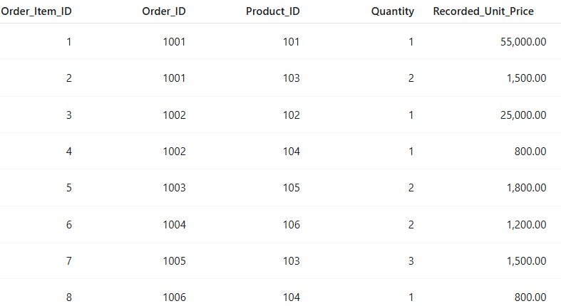
Order :
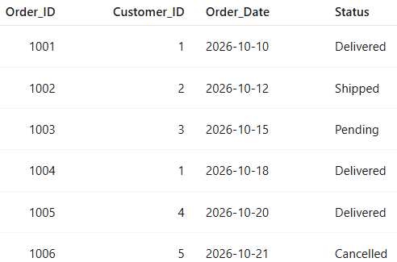
Payments
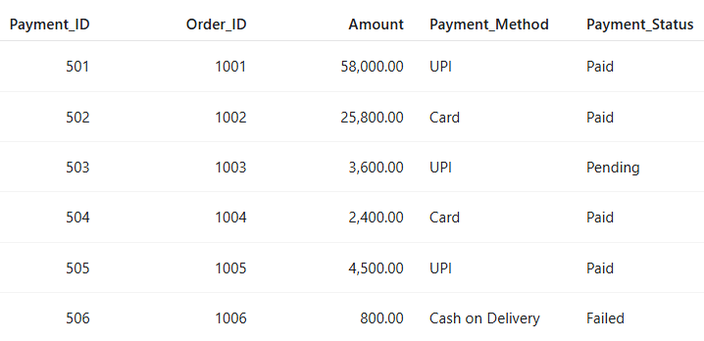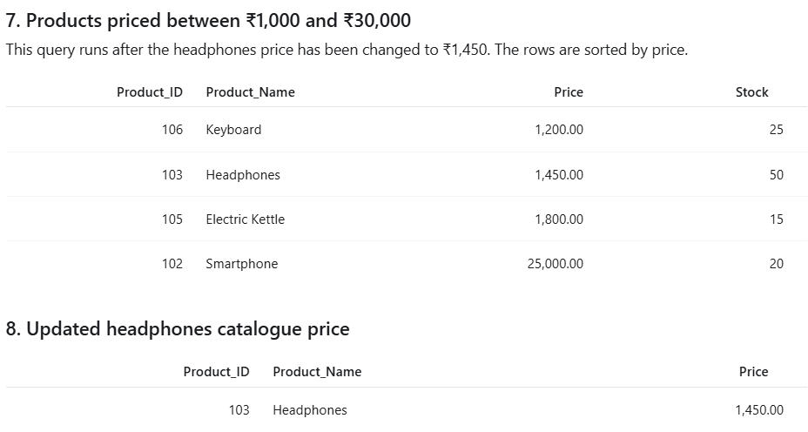j
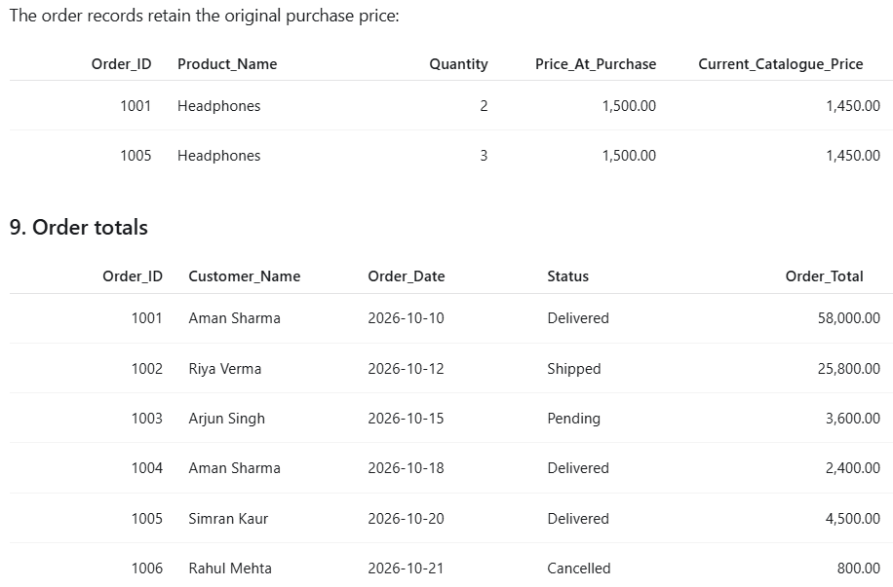

Aman Sharma’s order history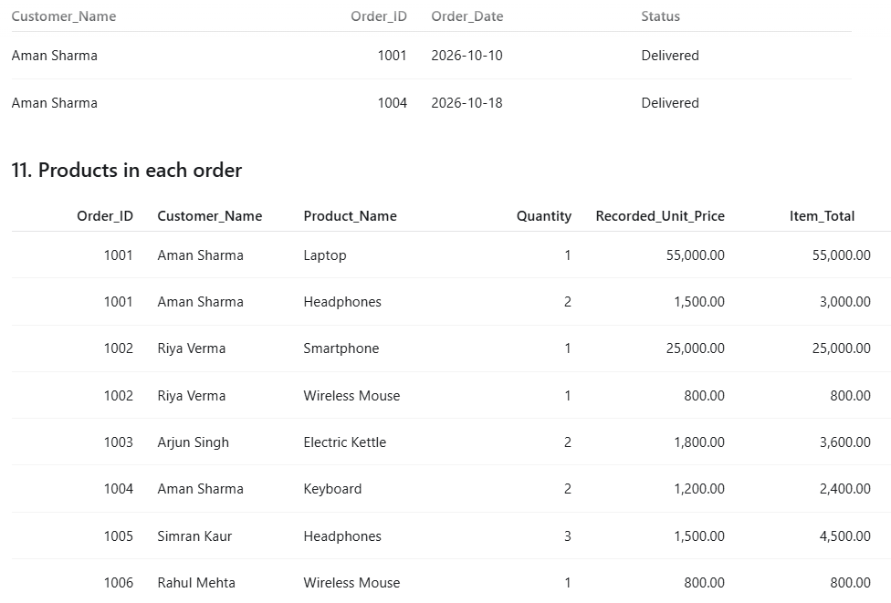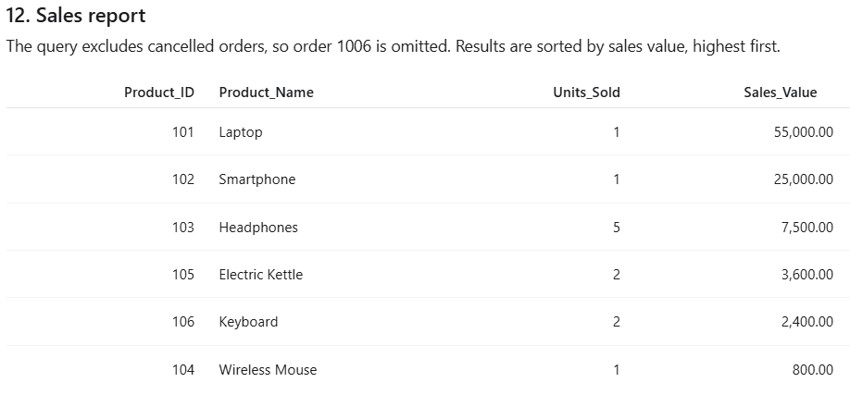
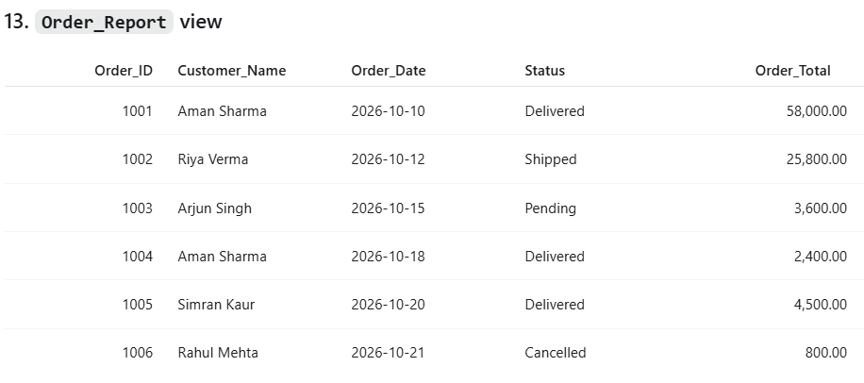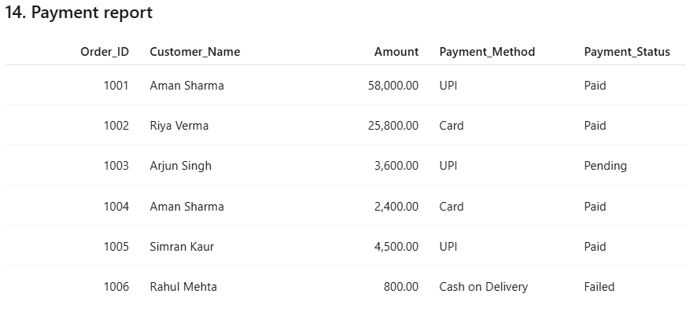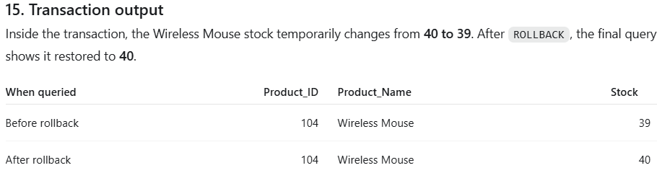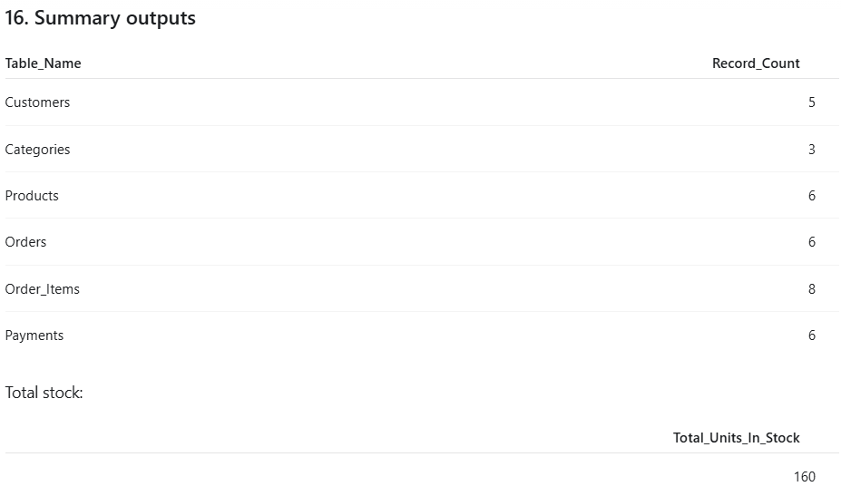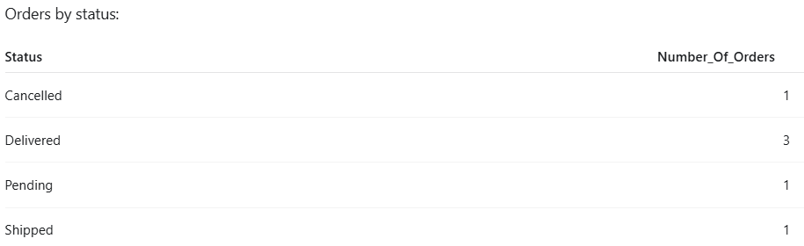
14.13 Analysis of the Results
After inserting the sample data and executing the queries, the database can provide useful information about Smart Buy's operations.
The database contains five customers, three categories, six products, six orders, eight order-item records, and six payment records. The product stock quantities add up to 160 units.
The order-total query shows that Order ID 1001 has the highest total value at ₹58,000. Order ID 1002 has a total of ₹25,800, while the other orders have smaller totals.
The sales report shows that the laptop generates the highest sales value in the sample records. Headphones have five units sold across the non-cancelled orders. The report excludes the Wireless Mouse item from the cancelled order when calculating sales.
These results show that SQL queries can convert stored records into useful information. The company can use the results to review order values, identify frequently purchased products, and understand the status of its orders.
14.14 Benefits to Smart Buy Online Store
The proposed system provides several benefits to the company.
First, it keeps customer and product information organised in a central database. Second, it reduces the need to calculate order totals manually. Third, it connects customers with their orders and products through relationships between tables.
The system also makes it easier to generate sales reports and search for products. Constraints help maintain valid records, while indexes can support suitable searches. The reporting view provides a convenient way to access order summaries.
Another benefit is the separation of current product prices from recorded order prices. This prevents a change in the catalogue price from automatically changing the value of an earlier order.
14.15 Limitations of the System
Although the database supports basic shopping operations, it has some limitations.
The project does not include a complete shopping website, customer login, shopping cart, or live payment gateway. Stock is not automatically reduced when a new order is inserted. Payment amounts and order totals are stored separately, and the current code does not automatically check that they match.
The database also uses a small sample dataset. A real shopping company would need more records, stronger access controls, backups, and additional testing to support everyday business operations.
14.16 Future Improvements
The system could be improved by adding a customer-facing website and an administrator panel. Customers could browse products, place orders, and view their order status. Administrators could add products, update prices, manage stock, and generate reports.
Further improvements could include automatic stock updates, payment gateway integration, delivery tracking, order cancellation procedures, refund management, and monthly sales reports.
The company could also add user authentication and role-based access controls so that only authorised users can make important changes to the database.
14.17 Conclusion of the Case Study
The Smart Buy Online Store case study demonstrates how a simple relational database can manage the main records of an online shopping business. The database stores customer information, product details, order records, individual order items, and payment information in six connected tables.
The practical example of Aman Sharma's order shows how the system records two products and calculates a total of ₹58,000. Other SQL queries display customer orders, calculate sales totals, filter products, and create reports.
The project also demonstrates the importance of keys, constraints, indexes, views, and transactions. Although it is a basic model and does not provide a complete online shopping website, it offers a clear understanding of how DBMS concepts are used in real business situations.
Overall, the case study shows that a well-organised database can make shopping records easier to maintain, search, and analyse.

